Slip – 2A

PublicClass **Form1**

Dim **x** AsInteger **= 0**

Dim **y** AsInteger **= 50**

PrivateSub **Timer1_Tick(**ByVal **sender** As **System.Object,** ByVal **e** As **System.EventArgs)** Handles **Timer1.Tick**

**Label1.Location =** New **Point(x, y)**

**x = x + 10**

If **x >** Me**.Width - Label1.Width** Then

**Timer1.Enabled =** False

**Timer2.Enabled =** True

EndIf

EndSub

PrivateSub **Timer2_Tick(**ByVal **sender** As **System.Object,** ByVal **e** As **System.EventArgs)** Handles **Timer2.Tick**

**Label1.Location =** New **Point(x, y)**

**x = x - 10**

If **x < 0** Then

**Timer2.Enabled =** False

**Timer1.Enabled =** True

EndIf

EndSub

PrivateSub **Button1_Click(**ByVal **sender** As **System.Object,** ByVal **e** As **System.EventArgs)** Handles **Button1.Click**

Dim **str** AsString **= TextBox1.Text**

**str = StrReverse(str)**

If **TextBox1.Text = str** Then

**MessageBox.Show(**"String is Palindrome"**)**

Else

**MessageBox.Show(**"String is not Palindrome"**)**

EndIf

EndSub

EndClass

Slip - 3B

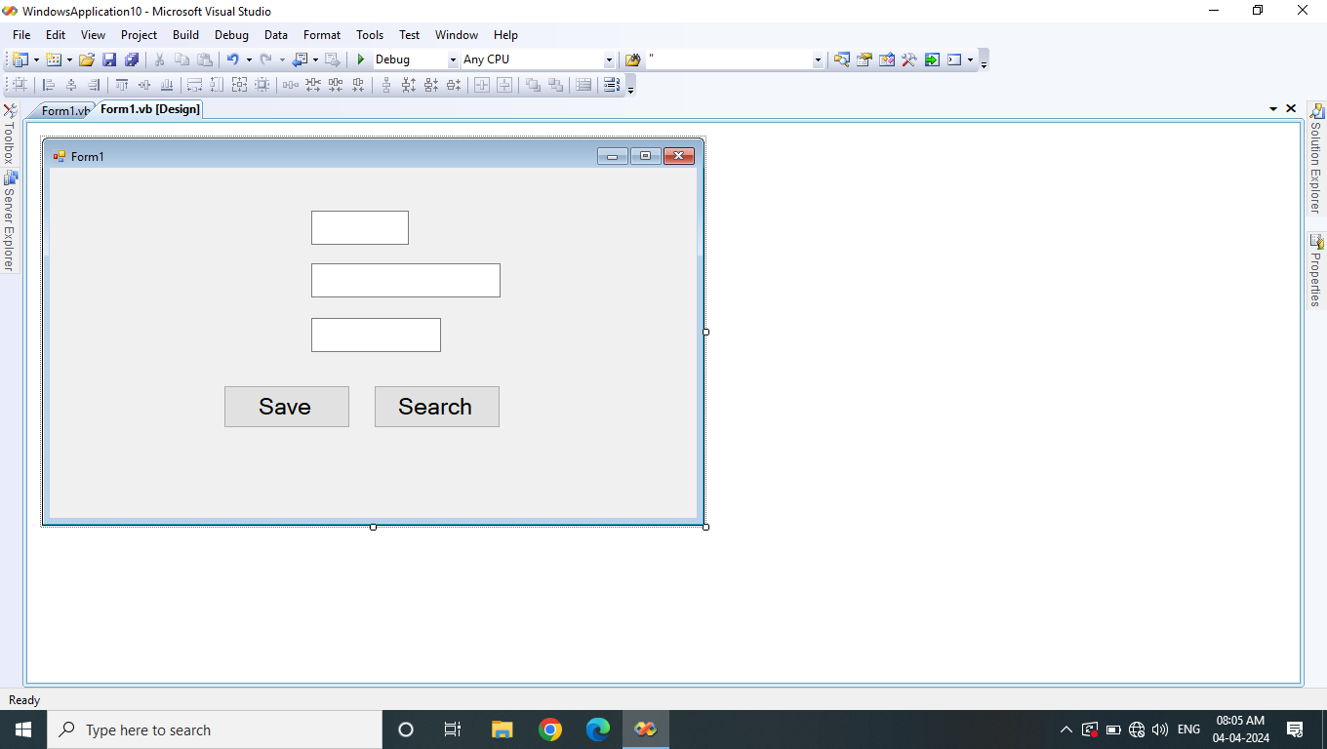

Imports **System.Data**

Imports **System.Data.SqlClient**

PublicClass **Form1**

Dim **conn** AsNew **SqlConnection(**"Data Source=.\sqlexpress;Initial Catalog=tybba;Integrated Security=True;Pooling=False"**)**

Dim **cmd** AsNew **SqlCommand**

Dim **dr** As **SqlDataReader**

PrivateSub **Button1_Click(**ByVal **sender** As **System.Object,** ByVal **e** As **System.EventArgs)** Handles **Button1.Click**

Try

**conn.Open()**

**cmd.Connection = conn**

**cmd.CommandText =** "insert into teacher values(" **+ TextBox1.Text +** ",'" **+ TextBox2.Text +** "','" **+ TextBox3.Text +** "')"

**cmd.ExecuteNonQuery()**

**MessageBox.Show(**"Record Saved Successfully"**)**

**TextBox1.Text =** ""

**TextBox2.Text =** ""

**TextBox3.Text =** ""

**TextBox1.Focus()**

Catch **ex** As **Exception**

**MessageBox.Show(**"Error " **+ ex.Message)**

Finally

**conn.Close()**

EndTry

EndSub

PrivateSub **Button2_Click(**ByVal **sender** As **System.Object,** ByVal **e** As **System.EventArgs)** Handles **Button2.Click**

Try

**conn.Open()**

**cmd.Connection = conn**

**cmd.CommandText =** "select * from teacher where tname='Seeta'"

**dr = cmd.ExecuteReader()**

If **dr.Read** Then

**TextBox1.Text = dr(0)**

**TextBox2.Text = dr(1)**

**TextBox3.Text = dr(2)**

Else

**MessageBox.Show(**"Record not found"**)**

EndIf

Catch **ex** As **Exception**

**MessageBox.Show(**"Error " **+ ex.Message)**

Finally

**conn.Close()**

EndTry

EndSub

EndClass

Slip – 4A

PrivateSub **DateTimePicker1_ValueChanged(**ByVal **sender** As **System.Object,** ByVal **e** As **System.EventArgs)** Handles **DateTimePicker1.ValueChanged**

**TextBox1.Text = DateTimePicker1.Value.Day**

**TextBox2.Text = DateTimePicker1.Value.Month**

**TextBox3.Text = DateTimePicker1.Value.Year**

EndSub

Slip – 19A

PrivateSub **Button1_Click(**ByVal **sender** As **System.Object,** ByVal **e** As **System.EventArgs)** Handles **Button1.Click**

Dim **str** AsString **= TextBox1.Text**

**str = StrReverse(str)**

If **TextBox1.Text = str** Then

**MessageBox.Show(**"String is Palindrome"**)**

Else

**MessageBox.Show(**"String is not Palindrome"**)**

EndIf

EndSub

Slip – 12B

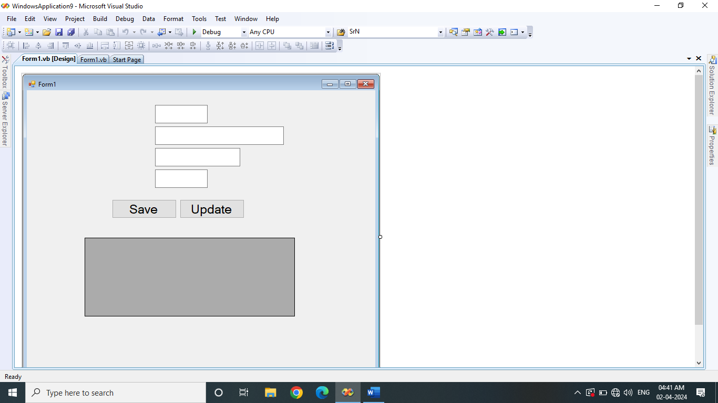

Imports **System.Data**

Imports **System.Data.SqlClient**

PublicClass **Form1**

Dim **con** AsNew **SqlConnection(**"Data Source=.\sqlexpress;Initial Catalog=tybba;Integrated Security=True;Pooling=False"**)**

Dim **cmd** AsNew **SqlCommand**

PrivateSub **Button1_Click(**ByVal **sender** As **System.Object,** ByVal **e** As **System.EventArgs)** Handles **Button1.Click**

Try

**con.Open()**

**cmd.Connection = con**

**cmd.CommandText =** "insert into player values(" **+ TextBox1.Text +** ",'" **+ TextBox2.Text +** "','" **+ TextBox3.Text +** "'," **+ TextBox4.Text +** ")"

**cmd.ExecuteNonQuery()**

**MessageBox.Show(**"Record saved successfuly"**)**

Catch **ex** As **Exception**

**MessageBox.Show(**"Error : " **+ ex.Message)**

Finally

**con.Close()**

EndTry

EndSub

PrivateSub **Button2_Click(**ByVal **sender** As **System.Object,** ByVal **e** As **System.EventArgs)** Handles **Button2.Click**

Try

**con.Open()**

**cmd.Connection = con**

**cmd.CommandText =** "update player set no_of_matches=500 where pname='Rohit Sharma'"

**cmd.ExecuteNonQuery()**

**MessageBox.Show(**"Record updated successfuly"**)**

Catch **ex** As **Exception**

**MessageBox.Show(**"Error : " **+ ex.Message)**

Finally

**con.Close()**

EndTry

EndSub

EndClass

Slip – 7

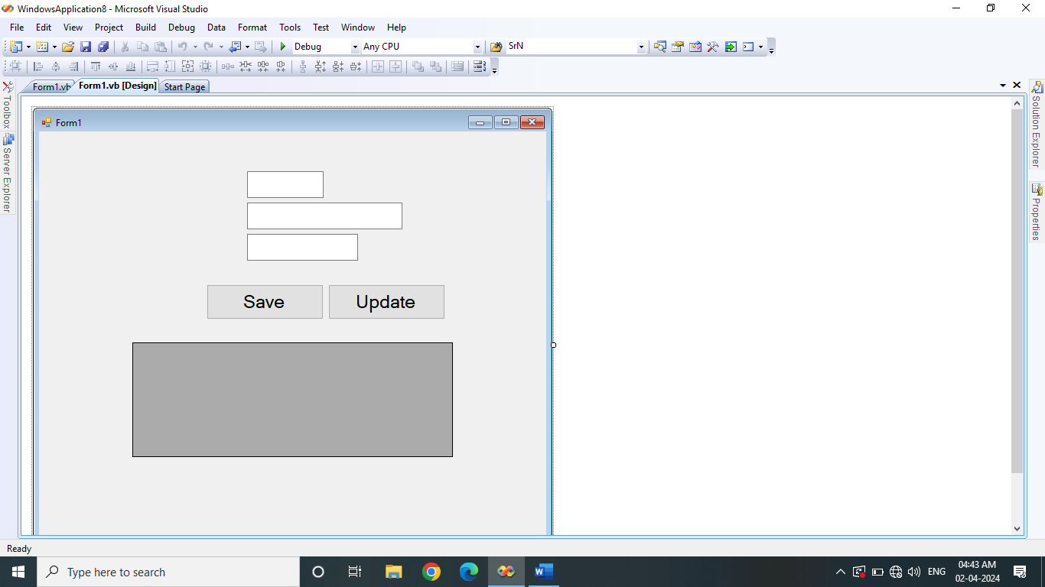

Imports **System.Data**

Imports **System.Data.SqlClient**

PublicClass **Form1**

Dim **con** AsNew **SqlConnection(**"Data Source=.\sqlexpress;Initial Catalog=demo;Integrated Security=True"**)**

Dim **cmd** AsNew **SqlCommand**

PrivateSub **Button1_Click(**ByVal **sender** As **System.Object,** ByVal **e** As **System.EventArgs)** Handles **Button1.Click**

Try

**con.Open()**

**cmd.Connection = con**

**cmd.CommandText =** "insert into student values(" **+ TextBox1.Text +** ",'" **+ TextBox2.Text +** "','" **+ TextBox3.Text +** "')"

**cmd.ExecuteNonQuery()**

**MessageBox.Show(**"Record inserted successfully"**)**

**TextBox1.Text =** ""

**TextBox2.Text =** ""

**TextBox3.Text =** ""

**TextBox1.Focus()**

Catch **ex** As **Exception**

**MessageBox.Show(**"Error : " **+ ex.Message)**

Finally

**con.Close()**

EndTry

EndSub

PrivateSub **Button2_Click(**ByVal **sender** As **System.Object,** ByVal **e** As **System.EventArgs)** Handles **Button2.Click**

Try

**con.Open()**

**cmd.Connection = con**

**cmd.CommandText =** "update student set city='Mumbai' where city='Pune'"

**cmd.ExecuteNonQuery()**

**MessageBox.Show(**"Record updated successfully"**)**

Catch **ex** As **Exception**

**MessageBox.Show(**"Error : " **+ ex.Message)**

Finally

**con.Close()**

EndTry

EndSub

EndClass

Slip – 4B

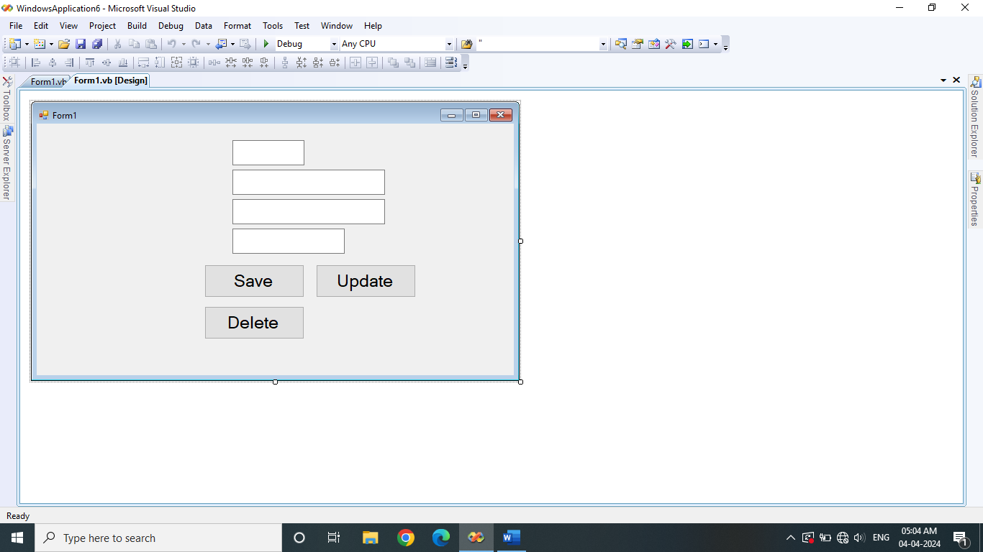

Imports **System.Data**

Imports **System.Data.SqlClient**

PublicClass **Form1**

Dim **con** AsNew **SqlConnection(**"Data Source=.\sqlexpress;Initial Catalog=demo;Integrated Security=True"**)**

Dim **cmd** AsNew **SqlCommand**

PrivateSub **Button1_Click(**ByVal **sender** As **System.Object,** ByVal **e** As **System.EventArgs)** Handles **Button1.Click**

Try

**con.Open()**

**cmd.Connection = con**

**cmd.CommandText =** "insert into dept values(" **+ TextBox1.Text +** ",'" **+ TextBox2.Text +** "','" **+ TextBox3.Text +** "'," **+ TextBox4.Text +** ")"

**cmd.ExecuteNonQuery()**

**MessageBox.Show(**"Record inserted successfuly"**)**

Catch **ex** As **Exception**

**MessageBox.Show(**"Error : " **+ ex.Message)**

Finally

**con.Close()**

EndTry

EndSub

PrivateSub **Button2_Click(**ByVal **sender** As **System.Object,** ByVal **e** As **System.EventArgs)** Handles **Button2.Click**

Try

**con.Open()**

**cmd.Connection = con**

**cmd.CommandText =** "update dept set salary=salary+(salary/100*15) where did=" **+ TextBox1.Text**

**cmd.ExecuteNonQuery()**

**MessageBox.Show(**"Record updated successfuly"**)**

Catch **ex** As **Exception**

**MessageBox.Show(**"Error : " **+ ex.Message)**

Finally

**con.Close()**

EndTry

EndSub

PrivateSub **Button3_Click(**ByVal **sender** As **System.Object,** ByVal **e** As **System.EventArgs)** Handles **Button3.Click**

Try

**con.Open()**

**cmd.Connection = con**

**cmd.CommandText =** "delete from dept where did=" **+ TextBox1.Text**

**cmd.ExecuteNonQuery()**

**MessageBox.Show(**"Record deleted successfuly"**)**

Catch **ex** As **Exception**

**MessageBox.Show(**"Error : " **+ ex.Message)**

Finally

**con.Close()**

EndTry

EndSub

EndClass

Slip – 6B

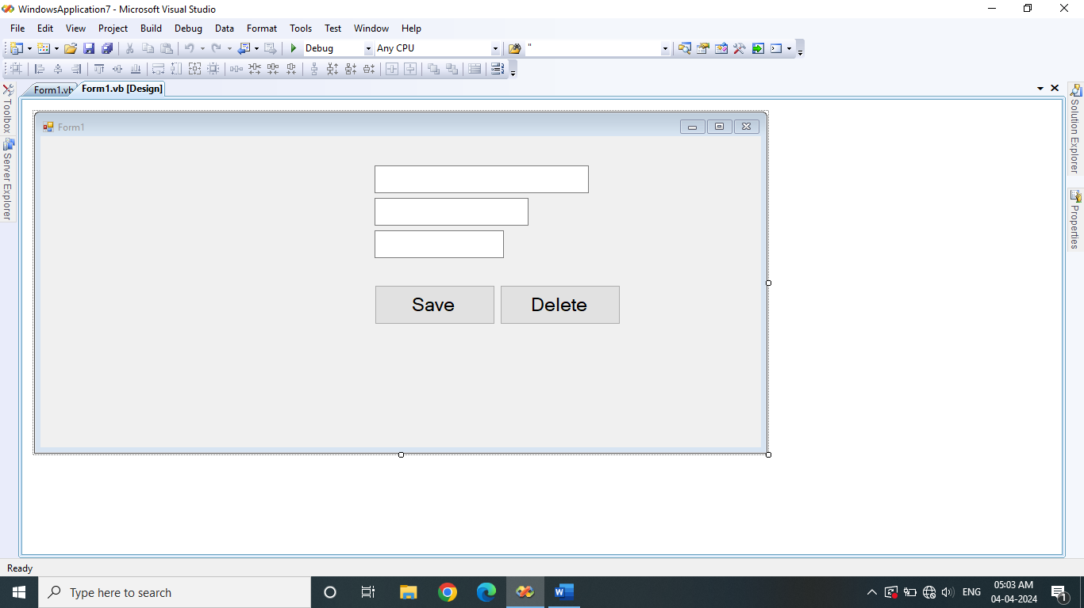

Imports **System.Data**

Imports **System.Data.SqlClient**

PublicClass **Form1**

Dim **con** AsNew **SqlConnection(**"Data Source=.\sqlexpress;Initial Catalog=demo;Integrated Security=True"**)**

Dim **cmd** AsNew **SqlCommand**

PrivateSub **Button1_Click(**ByVal **sender** As **System.Object,** ByVal **e** As **System.EventArgs)** Handles **Button1.Click**

Try

**con.Open()**

**cmd.Connection = con**

**cmd.CommandText =** "insert into movie values('" **+ TextBox1.Text +** "','" **+ TextBox2.Text +** "'," **+ TextBox3.Text +** ")"

**cmd.ExecuteNonQuery()**

**MessageBox.Show(**"Record inserted successfully"**)**

**TextBox1.Text =** ""

**TextBox2.Text =** ""

**TextBox3.Text =** ""

**TextBox1.Focus()**

Catch **ex** As **Exception**

**MessageBox.Show(**"Error : " **+ ex.Message)**

Finally

**con.Close()**

EndTry

EndSub

PrivateSub **Button2_Click(**ByVal **sender** As **System.Object,** ByVal **e** As **System.EventArgs)** Handles **Button2.Click**

Try

**con.Open()**

**cmd.Connection = con**

**cmd.CommandText =** "delete from movie where rel_year=2022"

**cmd.ExecuteNonQuery()**

**MessageBox.Show(**"Record deleted successfully"**)**

**TextBox1.Focus()**

Catch **ex** As **Exception**

**MessageBox.Show(**"Error : " **+ ex.Message)**

Finally

**con.Close()**

EndTry

EndSub

EndClass

C#

Slip – 2B

using **System;**

using **System.Collections.Generic;**

using **System.Linq;**

using **System.Text;**

namespace **ConsoleApplication1**

**{**

classDepartment

**{**

protectedint **id;**

protectedstring **name;**

publicvoid **accept()**

**{**

Console.Write("Enter Dept. ID : "**);**

**id =** Convert.ToInt32(Console.ReadLine());

Console.Write("Enter Dept. Name : "**);**

**name =** Console.ReadLine();

**}**

publicvoid **display()**

**{**

Console.WriteLine("Dept. ID : "+ id);

Console.WriteLine("Dept. Name : " **+ name);**

**}**

**}**

classSales **:** Department

**{**

protectedint **sales_amt;**

publicvoid **set()**

**{**

**accept();**

Console.Write("Enter Sales Amount : "**);**

**sales_amt =** Convert.ToInt32(Console.ReadLine());

**}**

publicvoid **get()**

**{**

**display();**

Console.WriteLine("Sales Amount : " **+ sales_amt);**

**}**

**}**

classHR **:** Department

**{**

protectedint **salary;**

publicvoid **set()**

**{**

**accept();**

Console.Write("Enter Salary Amount : "**);**

**salary =** Convert.ToInt32(Console.ReadLine());

**}**

publicvoid **get()**

**{**

**display();**

Console.WriteLine("Salary Amount : " **+ salary);**

**}**

**}**

classProgram

**{**

staticvoid **Main(**string**[] args)**

**{**

Sales **s =** newSales**();**

HR **h =** newHR**();**

**s.set();**

**h.set();**

**s.get();**

**h.get();**

Console.ReadKey();

**}**

**}**

**}**

Slip – 3A

using **System;**

using **System.Collections.Generic;**

using **System.Linq;**

using **System.Text;**

namespace **ConsoleApplication2**

**{**

classProgram

**{**

staticvoid **sum(**int **n1,**int **n2)**

**{**

Console.WriteLine("Add is : " **+ (n1 + n2));**

**}**

staticvoid **Main(**string**[] args)**

**{**

int **n1, n2;**

Console.Write("Enter No1 : "**);**

**n1 =** Convert.ToInt32(Console.ReadLine());

Console.Write("Enter No2 : "**);**

**n2 =** Convert.ToInt32(Console.ReadLine());

**sum(n1, n2);**

Console.ReadKey();

**}**

**}**

**}**

Slip 11B

using **System;**

using **System.Collections.Generic;**

using **System.Linq;**

using **System.Text;**

namespace **ConsoleApplication3**

**{**

classFruit

**{**

staticprotectedint **cnt = 0;**

staticpublicvoid **count()**

**{**

Console.WriteLine("Total Fruits are : " **+ cnt);**

**}**

**}**

classMango **:** Fruit

**{**

staticint **mcnt = 0;**

publicvoid **buy()**

**{**

**mcnt++;**

**cnt++;**

**}**

publicvoid **mango_cnt()**

**{**

Console.WriteLine("Total Mangoes are : " **+ mcnt);**

**}**

**}**

classApple **:** Fruit

**{**

staticint **acnt = 0;**

publicvoid **buy()**

**{**

**acnt++;**

**cnt++;**

**}**

publicvoid **apple_cnt()**

**{**

Console.WriteLine("Total Apples are : " **+ acnt);**

**}**

**}**

classProgram

**{**

staticvoid **Main(**string**[] args)**

**{**

Mango **m =** newMango**();**

Apple **a =** newApple**();**

**m.buy();**

**m.buy();**

**a.buy();**

**a.buy();**

**a.buy();**

**a.buy();**

**m.mango_cnt();**

**a.apple_cnt();**

Fruit.count();

Console.ReadKey();

**}**

**}**

**}**

Slip – 13B

using **System;**

using **System.Collections.Generic;**

using **System.Linq;**

using **System.Text;**

namespace **ConsoleApplication4**

**{**

classStudent

**{**

int **rno;**

string **name;**

int **s1, s2, s3, tot;**

float **per;**

publicvoid **accept()**

**{**

Console.WriteLine("Enter Student Details : "**);**

Console.Write("Roll No : "**);**

**rno =** Convert.ToInt32(Console.ReadLine());

Console.Write("Name : "**);**

**name =** Console.ReadLine();

Console.Write("Sub. 1 Marks : "**);**

**s1 =** Convert.ToInt32(Console.ReadLine());

Console.Write("Sub. 2 Marks : "**);**

**s2 =** Convert.ToInt32(Console.ReadLine());

Console.Write("Sub. 3 Marks : "**);**

**s3 =** Convert.ToInt32(Console.ReadLine());

**tot = s1 + s2 + s3;**

**per = tot / 3;**

**}**

publicvoid **display()**

**{**

Console.WriteLine("Student Details : "**);**

Console.WriteLine("Roll No : "+rno);

Console.WriteLine("Name : "+name);

Console.WriteLine("Sub. 1 Marks : "+s1);

Console.WriteLine("Sub. 2 Marks : "+s2);

Console.WriteLine("Sub. 3 Marks : "+s3);

Console.WriteLine("Total Marks : " **+ tot);**

Console.WriteLine("Per. Marks : " **+ per);**

**}**

staticvoid **Main(**string**[] args)**

**{**

int **n,i;**

Console.WriteLine("Enter No. of Students : "**);**

**n =** Convert.ToInt32(Console.ReadLine());

Student **[]s =** newStudent**[n];**

for **(i = 0; i < n; i++)**

**{**

**s[i] =** newStudent**();**

**s[i].accept();**

**}**

for **(i = 0; i < n; i++)**

**{**

**s[i].display();**

**}**

Console.ReadKey();

**}**

**}**

**}**

Slip – 28A

using **System;**

using **System.Collections.Generic;**

using **System.Linq;**

using **System.Text;**

namespace **ConsoleApplication5**

**{**

classProgram

**{**

staticvoid **Main(**string**[] args)**

**{**

int **n,i;**

Console.Write("Enter Array Size : "**);**

**n =** Convert.ToInt32(Console.ReadLine());

int **[]arr =** newint**[n];**

Console.WriteLine("Enter Array Elements : "**);**

for **(i = 0; i < n; i++)**

**{**

**arr[i] =** Convert.ToInt32(Console.ReadLine());

**}**

Console.WriteLine("Array Elements before reverse : "**);**

for **(i = 0; i < n; i++)**

**{**

Console.WriteLine(arr[i]);

**}**

int **j = n - 1;**

for **(i = 0; i < j; i++)**

**{**

int **temp;**

**temp = arr[i];**

**arr[i] = arr[j];**

**arr[j] = temp;**

**j--;**

**}**

Console.WriteLine("Array Elements after reverse : "**);**

for **(i = 0; i < n; i++)**

**{**

Console.WriteLine(arr[i]);

**}**

Console.ReadKey();

**}**

**}**

**}**

Slip – 17 A

using **System;**

using **System.Collections.Generic;**

using **System.Linq;**

using **System.Text;**

namespace **ConsoleApplication5**

**{**

classProgram

**{**

staticvoid **Main(**string**[] args)**

**{**

string **str;**

Console.Write("Enter String : "**);**

**str =** Console.ReadLine();

Console.WriteLine("Vowels from the strings are : "**);**

for **(**int **i = 0; i < str.Length; i++)**

**{**

if **(str[i] ==** 'A' **|| str[i] ==** 'E' **|| str[i] ==** 'I' **|| str[i] ==** 'O' **|| str[i] ==** 'U' **|| str[i] ==** 'a' **|| str[i] ==** 'e' **|| str[i] ==** 'i' **|| str[i] ==** 'o' **|| str[i] ==** 'u'**)**

**{**

Console.WriteLine(str[i]);

**}**

**}**

Console.ReadKey();

**}**

**}**

**}**

Slip – 28 A

using **System;**

using **System.Collections.Generic;**

using **System.Linq;**

using **System.Text;**

namespace **ConsoleApplication5**

**{**

classProgram

**{**

staticvoid **Main(**string**[] args)**

**{**

int **n,i;**

Console.Write("Enter Array Size : "**);**

**n =** Convert.ToInt32(Console.ReadLine());

int **[]arr =** newint**[n];**

Console.WriteLine("Enter Array Elements : "**);**

for **(i = 0; i < n; i++)**

**{**

**arr[i] =** Convert.ToInt32(Console.ReadLine());

**}**

Console.WriteLine("Array Elements before reverse : "**);**

for **(i = 0; i < n; i++)**

**{**

Console.WriteLine(arr[i]);

**}**

int **j = n - 1;**

for **(i = 0; i < j; i++)**

**{**

int **temp;**

**temp = arr[i];**

**arr[i] = arr[j];**

**arr[j] = temp;**

**j--;**

**}**

Console.WriteLine("Array Elements after reverse : "**);**

for **(i = 0; i < n; i++)**

**{**

Console.WriteLine(arr[i]);

**}**

Console.ReadKey();

**}**

**}**

**}**

Slip – 16A

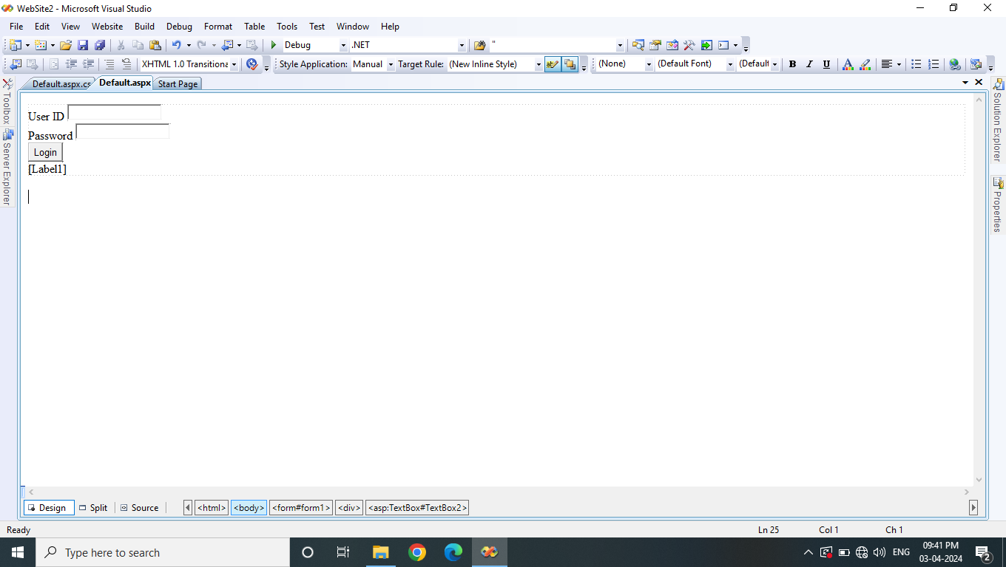

protectedvoid **Button1_Click(**object **sender,** EventArgs **e)**

**{**

if **(TextBox1.Text ==** "DYP" **&& TextBox2.Text ==** "Primpri"**)**

**{**

//Label1.Text = "Login Successful";

**Response.Write(**"<script>alert('Login Successful');</script>"**);**

**}**

else

**{**

**Label1.Text =** "Login Unsuccessful"**;**

**}**

**}**

Slip 7A

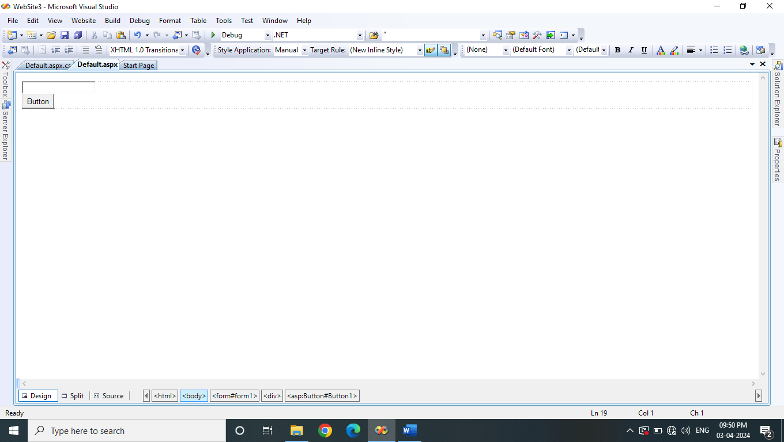

protectedvoid **Button1_Click(**object **sender,** EventArgs **e)**

**{**

try

**{**

int **no =** Convert.ToInt32(TextBox1.Text);

int **sum = 0;**

for **(**int **i = 1; i < no; i++)**

**{**

if **(no % i == 0)**

**{**

**sum = sum + i;**

**}**

**}**

if **(sum == no)**

**{**

**Response.Write(**"Perfect Number"**);**

**}**

else

**{**

**Response.Write(**"Not a Perfect Number"**);**

**}**

**}**

catch **(**Exception **ex)**

**{**

**Response.Write(**"Please enter correct integer number"**);**

**TextBox1.Text =** ""**;**

**TextBox1.Focus();**

**}**

**}**

Slip – 19B

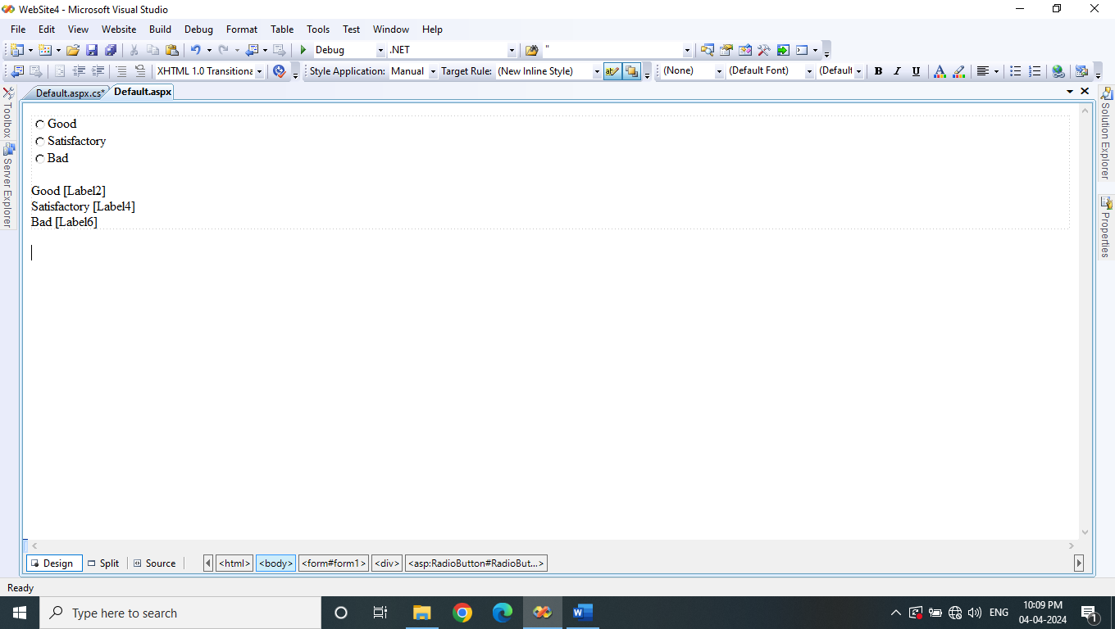

using **System;**

using **System.Configuration;**

using **System.Data;**

using **System.Linq;**

using **System.Web;**

using **System.Web.Security;**

using **System.Web.UI;**

using **System.Web.UI.HtmlControls;**

using **System.Web.UI.WebControls;**

using **System.Web.UI.WebControls.WebParts;**

using **System.Xml.Linq;**

publicpartialclass_Default **: System.Web.UI.**Page

**{**

float **per;**

protectedvoid **Page_Load(**object **sender,** EventArgs **e)**

**{**

**}**

protectedvoid **RadioButton1_CheckedChanged(**object **sender,** EventArgs **e)**

**{**

**Session[**"tot"**] =** Convert.ToInt32(Session["tot"**]) + 1;**

**Session[**"good"**] =** Convert.ToInt32(Session["good"**]) + 1;**

**per = 100 \*** Convert.ToInt32(Session["good"**]) /** Convert.ToInt32(Session["tot"**]);**

**Label2.Text = per.ToString();**

**per = 100 \*** Convert.ToInt32(Session["sat"**]) /** Convert.ToInt32(Session["tot"**]);**

**Label4.Text = per.ToString();**

**per = 100 \*** Convert.ToInt32(Session["bad"**]) /** Convert.ToInt32(Session["tot"**]);**

**Label6.Text = per.ToString();**

**}**

protectedvoid **RadioButton2_CheckedChanged(**object **sender,** EventArgs **e)**

**{**

**Session[**"tot"**] =** Convert.ToInt32(Session["tot"**]) + 1;**

**Session[**"sat"**] =** Convert.ToInt32(Session["sat"**]) + 1;**

**per = 100 \*** Convert.ToInt32(Session["good"**]) /** Convert.ToInt32(Session["tot"**]);**

**Label2.Text = per.ToString();**

**per = 100 \*** Convert.ToInt32(Session["sat"**]) /** Convert.ToInt32(Session["tot"**]);**

**Label4.Text = per.ToString();**

**per = 100 \*** Convert.ToInt32(Session["bad"**]) /** Convert.ToInt32(Session["tot"**]);**

**Label6.Text = per.ToString();**

**}**

protectedvoid **RadioButton3_CheckedChanged(**object **sender,** EventArgs **e)**

**{**

**Session[**"tot"**] =** Convert.ToInt32(Session["tot"**]) + 1;**

**Session[**"bad"**] =** Convert.ToInt32(Session["bad"**]) + 1;**

**per = 100 \*** Convert.ToInt32(Session["good"**]) /** Convert.ToInt32(Session["tot"**]);**

**Label2.Text = per.ToString();**

**per = 100 \*** Convert.ToInt32(Session["sat"**]) /** Convert.ToInt32(Session["tot"**]);**

**Label4.Text = per.ToString();**

**per = 100 \*** Convert.ToInt32(Session["bad"**]) /** Convert.ToInt32(Session["tot"**]);**

**Label6.Text = per.ToString();**

**}**

**}**